Section 1: Case Summary

Scenario Title: | Ventricular Tachycardia
Keywords: | Cardiology, ACLS, VT, Shockable Rhythm
Brief Description of Case: | In this scenario, the learner is called to the ward to assess a 65 y/o male with new VT. The learner must recognize the rhythm and institute appropriate work-up and management including electrical cardioversion.

Goals and Objectives
Educational Goal: | Demonstrate an organized approach to the unstable patient.
Objectives:  (Medical and CRM) | - Recognize VT on an ECG  - Initiate appropriate ACLS management for VT  - Determine a safe disposition and transfer of care
EPAs Assessed:

Learners, Setting and Personnel
Target Learners: | ☒ Junior Learners |  | ☐ Senior Learners |  |  | ☐ Staff
 | ☐ Physicians | ☐ Nurses |  |  | ☐ RTs |  |  | ☐ Inter-professional
 | ☐ Other Learners:
Location: | ☒ Sim Lab |  |  | ☐ In Situ |  |  | ☐ Other:
Recommended Number of Facilitators | Instructors: 1
 | Confederates: 1 (RN)
 | Sim Techs: 1

Scenario Development
Date of Development: | 2015
Scenario Developer(s): | Dr. Tim Chaplin
Affiliations/Institutions(s): | Queen’s University
Contact E-mail: | chaplintim2@gmail.com
Last Revision Date: | Nov 2019
Revised By: | Dr. Jared Baylis
Version Number: | 1

Section 2A: Initial Patient Information

- Patient Chart
Patient Name: Surrinder Singh |  |  | Age: 65 |  |  | Gender: M |  | Weight: 90kg
Presenting complaint: Palpitations
Temp: 36.5 | HR: 150 | BP: 122/80 |  |  | RR: 20 |  | O₂Sat: 92% |  | FiO₂: room air
Cap glucose: 8.7 |  |  |  |  | GCS: 15
Triage note:
You are called by the ward nurse to assess a 65 y/o male with a new onset “rapid heart rate”. This patient was admitted early yesterday and is awaiting a coronary angiogram for an NSTEMI.

Allergies: NKDA
Past Medical History:  Type 2 diabetes mellitus |  |  |  | Current Medications:  ASA 81mg PO daily  Metformin 1000mg PO BID

Section 2B: Extra Patient Information

A. Further History
There are no symptoms aside from a sensation of anxiety and apprehensiveness.
B. Physical Exam
List any pertinent positive and negative findings
Cardio: Normal heart sounds, pulse rapid but palpable | Neuro: no neurologic deficits
Resp: nil | Head & Neck: nil
Abdo: nil | MSK/skin: nil
Other: The patient appears anxious.

Section 3: Technical Requirements/Room Vision

A. Patient
☒ Mannequin – Adult
☐ Standardized Patient
☐ Task Trainer
☐ Hybrid
B. Special Equipment Required
Defibrillator
BVM
Non rebreather
Nasal prongs
Basic airway equipment

C. Required Medications
ACLS meds

D. Moulage
One PIV in the right antecubital fossa

E. Monitors at Case Onset
☒ Patient on monitor with vitals displayed
☐ Patient not yet on monitor
F. Patient Reactions and Exam
Patient is anxious and apprehensive
Will endorse that he feels his heart racing
Will deny any chest pain or shortness of breath

Section 4: Confederates and Standardized Patients

Confederate and Standardized Patient Roles and Scripts
Role | Description of role, expected behavior, and key moments to intervene/prompt learners. Include any script required (including conveying patient information if patient is unable)
Ward Nurse | The ward nurse present in the room should have a headset to allow communication with the control room. They will be the nurse that called the resident to assess the patient and will be familiar with their past medical history and medications. Nurse will be helpful and non-obstructive.

Section 5: Scenario Progression

Scenario States, Modifiers and Triggers
Patient State/Vitals | Patient Status | Learner Actions, Modifiers & Triggers to Move to Next State |  | Facilitator Notes
1. Baseline State  Rhythm: VT  HR: 150  BP: 122/80  RR: 20  O₂SAT: 92%  T: 37ºC  GCS: 15 | Patient is anxious and apprehensive. | Expected Learner Actions  Apply defibrillator pads  Complete pulse check  Order stat ECG and labs  Begin ACLS algorithm of stable wide-complex tachycardia  Apply supplemental oxygen  Call for help  Ensure IV access | Modifiers  - Start amio/procaine/sotalol no change to rhythm  - Electrical cardioversion attempted no change in rhythm  - O₂ sat increase to 94%  Triggers  - 3 minutes or attempt at cardioversion Phase 2
2. Unstable  Rhythm: VT  HR: 150  BP: 85/65  RR: 26  O₂SAT: 88%  GCS: 14 | Patient starts to complain of SOB and chest heaviness | Expected Learner Actions  Recognize change in status  Initiate ACLS for unstable tachycardia with a pulse  Provide analgesia for shock  Synchronized cardioversion  Call cardiology/ICU | Modifiers  Triggers  - No shock within 3 minutes Phase 3  - Shock given Phase 4
3. Pulseless  Rhythm: Pulseless VT  HR: 150 (no pulse)  BP: 0  RR: 0  O₂SAT: 0  GCS: 3 |  | Expected Learner Actions  Provide high quality CPR  Provide BVM ventilation  Consider intubation  Provide defibrillation  Call cardiology/ICU | Modifiers  -  -  -  Triggers  - Defibrillation Phase 4
4. Disposition  Rhythm: Sinus  HR: 90  BP: 110/80  RR: 18  O₂SAT: 94% on NP  GCS: 15 | Patient drowsy but GCS 15. Asking what happened. | Expected Learner Actions  Recheck vitals and complete reassessment of patient post cardioversion  Handover care to cardiology/ICU

Appendix A: Laboratory Results

*Note: No labs will be provided during this scenario.

Appendix B: ECGs, X-rays, Ultrasounds and Pictures

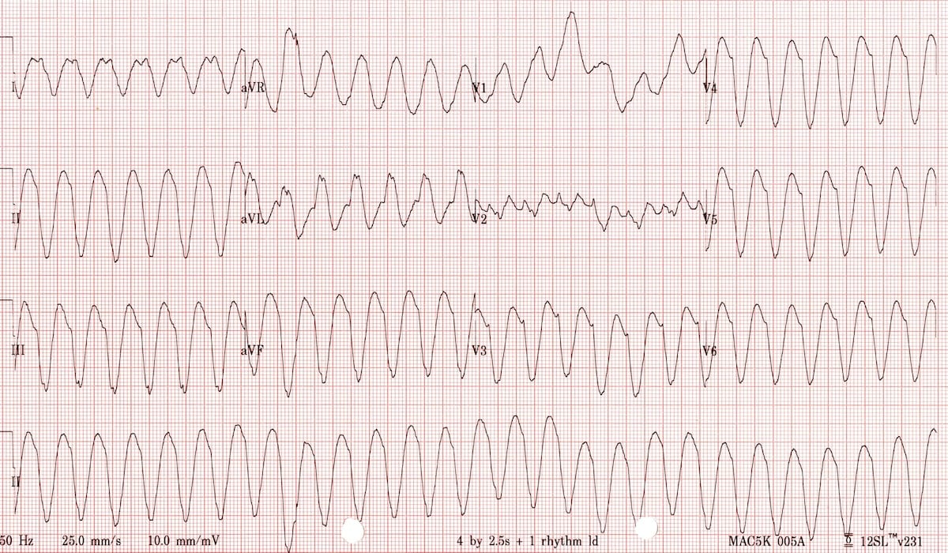
https://litfl.com/ventricular-tachycardia-monomorphic-ecg-library/

Appendix C: Facilitator Cheat Sheet & Debriefing Tips

Debrief topics:
- Clear communication within the team (RN, RT)
- Initial approach to the stable patient
- Criteria for the unstable patient
- General approach to VT
- Review of ACLS algorithms and supporting evidence
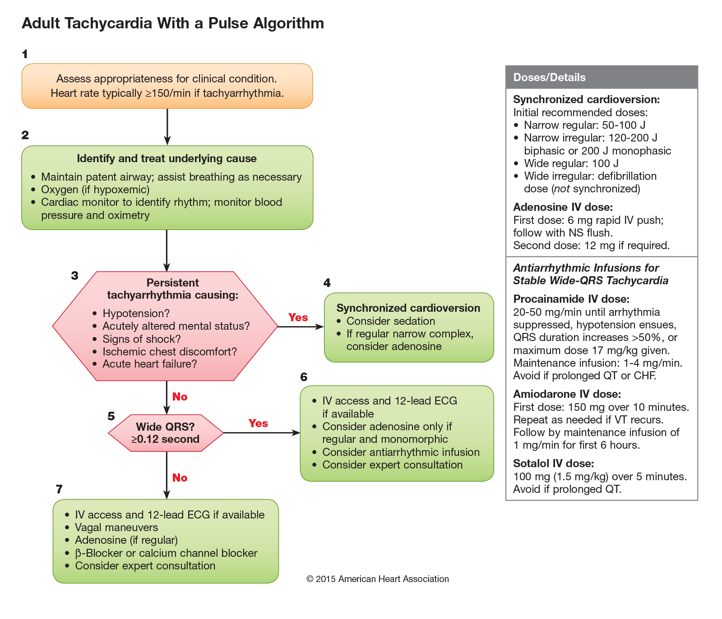
https://eccguidelines.heart.org/wp-content/uploads/2015/10/2010-Integrated_Updated-Circulation-ACLS-Tachycardia-Algorithm.png

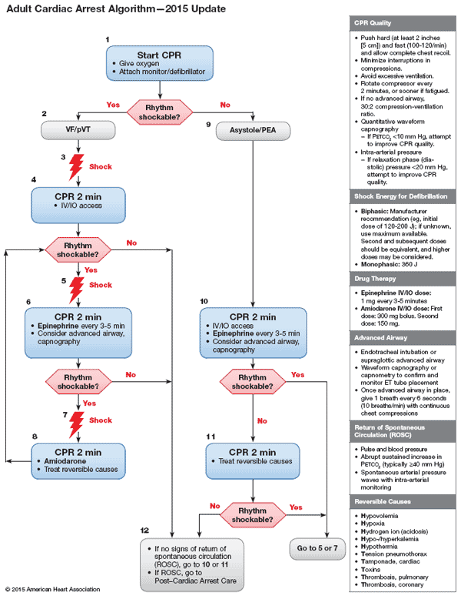
https://eccguidelines.heart.org/wp-content/uploads/2018/10/ACLS-Cardiac-Arrest-Algorithm-2018.png

References

1. ACLS 2015 Guidelines: https://ahajournals.org/doi/10.1161/CIR.0000000000000261
2. ACLS 2019 Focused Update: https://www.ahajournals.org/doi/10.1161/CIR.0000000000000732
3. LITFL VTach: https://litfl.com/ventricular-tachycardia-monomorphic-ecg-library/

